Managing Interface Specifications

Since interfaces are where most systems commonly fail, the way to succeed is to have clear interface definitions as well as a clear and concise way to track those interface interactions. You can do this through an interface matrix. This tool will allow you to document interfaces between subsystems, track interfaces throughout the design process, and assign responsibilities and estimates for delivery dates.
If you and your team use the interface matrix correctly, you have met an important precondition for creating a successfully performing system.

Interface Matrix Template

Download the Tool
Interface Matrix TemplateLinks to an external site.
Interface Matrix ChecklistLinks to an external site.
Interface Matrix Basic SampleLinks to an external site.
An Interface Matrix is an accounting of what information needs to be shared across various subsystems during design. It includes which subsystems are responsible for which information and when. It also serves as a means for providing updates to designers of different subsystems when a design change is made to any subsystem. The Interface Matrix even includes a mechanism for ensuring that proposed subsystem changes are discussed with all teams that might be influenced before a change is implemented.
There are some custom software packages that can be used to assist with Interface Matrix development, but for many projects a simple spreadsheet can achieve results that are just as effective.
The Basic Interface Matrix template is intended for typical project needs, and the associated Interface Matrix Checklist will guide you through the process. An Interface Matrix Basic Sample is also provided to show you what a typical completed interface matrix looks like. Click the provided links to download the template and checklist.
If you would like to create a more robust version of your Interface Matrix, including bidirectional communication lists and system-level budgeting, you may wish to use the Advanced Interface Matrix SampleLinks to an external site. and adapt the basic template as needed. Dr. Schneider goes into further detail about this advanced matrix later in the course.
Note: The steps in the Interface Matrix Checklist have been taken from the How to Create an Interface MatrixLinks to an external site. guide. This course will take you through each of these steps. However, before you begin, you are encouraged to read through all the steps to get an overview and see how they all fit together. With the big picture in mind, you may find it useful to do some of the steps at the same time.

Set up the Interface Matrix
In this activity, you will set up your interface matrix with your subsystems categories and identify specific pieces of information that needs to be provided to other subsystems.
Task: Set up the Interface Matrix
Instructions:
You will be entering values into a spreadsheet based on a system you are developing. This work should build on previous interface discovery.
Step 1:
If you haven't already done so, download the Interface Matrix TemplateLinks to an external site.. Open the template.
Step 2:
On the first sheet of the Interface Matrix Template, list the names of all your system's subsystems as headers of each column along the top row. The template is prepopulated with three columns for subsystems, so you may need to add or remove columns.
Note: For the purpose of this activity, you will only complete one sheet for one subsystem. If you were creating a real interface matrix, you would then create a copy of the provided sheet for each subsystem in the template and label each sheet (tab) with the name of one of the other subsystems.
Step 3:
Find the column with the header "Subsystem A Design Details," which should be column Q. Change the column header to reflect the current subsystem you're working with. Below the header, make a list of all of the aspects of this subsystem that may influence other subsystems.
Step 4:
For each piece of information listed about the current subsystem you're working with, determine which other subsystems may need this information. Add the words “Provide To” to the cells that correspond to information provided to other subsystems by the current subsystem. For example, if “Total volume” needs to be supplied to Subsystems B and C, “Provide to” will appear in the Subsystem B and Subsystem C columns for that row.
Note: The wording “Provided To” can also be abbreviated or changed if it is more convenient. The important thing is that the idea is made clear and that abbreviation or change is made consistently throughout the entire interface matrix.
Step 5:
Update the the tab and title of the sheet to reflect the subsystem's name (e.g. Power). Even though you will be completing only one sheet for this activity, it's a good habit to get into since it will help you stay organized when you need to work with a large number of subsystems.
This is Complete When...
Your interface matrix has one sheet in which you have have identified all subsystems in your system.
You have indicated where you need information from your current subsystem to be supplied to other subsystems by including the text “Provided To” or an equivalent abbreviation in the appropriate cells beneath the other subsystems' column headers.
Worked Example
In the supplied basic interface matrix sample, the locomotion subsystem team began by adding the following information about their motor that the other teams may need to know: motor voltage, motor current, power rating, motor encoder count, maximum duration usage, and motor weight.
In this case, the locomotion team will provide information about motor voltage, motor current, and power rating to the power subsystem team.
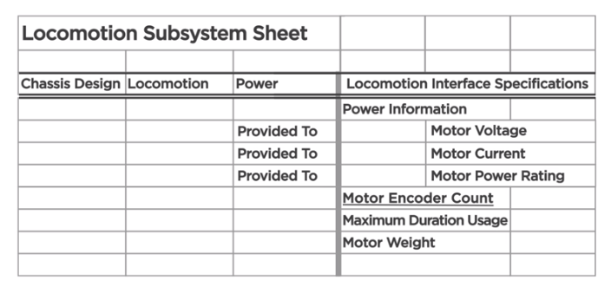
Notice that the interface specification information is listed in a kind of hierarchical format to make it easier to read. The row "Power Information" under the Locomotion Interface Specifications column is used as a header row for the Motor Voltage, Motor Current, and Motor Power Rating. Using headers in this way makes it easier to categorize specifications.

